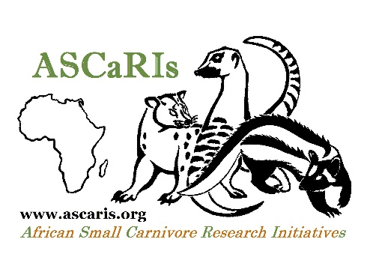
ASCaRIs Head Office
University of Fort Hare
Zoology Building
Third Floor, Room ZOT22
King Williams’ Town Road
Alice 5700, Eastern Cape
South Africa

Email: ascaris.org@gmail.com
Fax: +27 (0)86 628 2202

SPECIES ID TEMPLATE

ASCaRIS members – notably those with expertise on particular species – who want to assist us in preparing the short species ID cards are welcome to fill in the form below and provide us with the relevant information. Kindly refer to some completed profiles (on the website) to provide the needed information accordingly.

Please note that in order to ensure consistency some of the information you provide might be slightly edited before it is uploaded on the website. Thanks in advance for your precious assistance and understanding!

HB: head and body length – T: tail length – W: weight

Species name: xxx

HB: xx-yy cm
T: xx-yy cm
W: x.x-y.y kg

Distribution: xxx

Habitat: xxx

Diet: xxx

Activity: xxx

Social behaviour: xxx

Threats: xxx

