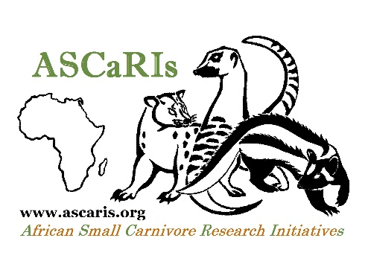
ASCaRIs Head Office
University of Fort Hare
Zoology Building
Third Floor, Room ZOT22
King Williams’ Town Road
Alice 5700, Eastern Cape
South Africa

Email: ascaris.org@gmail.com
Fax: +27 (0)86 628 2202

GUIDELINES TO FORMAT REFERENCES FOR UPLOAD ON THE WEBSITE

By following the formatting guidelines below you will allow us so save some precious time, but mostly this will ensure almost immediate upload of your publications on the website. When relevant, please do not forget to provide a DOI or the URL of a website where each publication can be downloaded. The DOIs or URLs will not be provided on the website; instead a link will be established between each reference and the corresponding webpage.

Please do not include publications that do not deal with at least with one species of African small carnivore.

Journal articles

Begg, C.M., Begg, K.S., du Toit, J.T. & Mills, M.G.L. (2003). Scent-marking behaviour of the honey badger, Mellivora capensis (Mustelidae) in the southern Kalahari. Animal Behaviour 66: 917–929.

Waser, P.M. (1980). Small nocturnal carnivores: ecological studies in the Serengeti. African Journal of Ecology 18: 167–185.

Books

Caro, T. (1994). Cheetah of the Serengeti Plains: Group Living in an Asocial Species. University of Chicago Press, Chicago, USA.

Burnham, K.P. & Anderson, D.R. (2002) Model Selection and Multimodel Inference: A Practical Information-theoretic Approach. Second edition. Springer, New York, USA.

Edited books

Proulx, G. & Do Linh San, E., editors (2016). Badgers: Systematics, Biology, Conservation and Research Techniques. Alpha Wildlife Publications, Sherwood Park, Canada.

Edited journal issues

Do Linh San, E. & Somers, M.J., editors (2013). Special issue: Africa. Small Carnivore Conservation 48: 1–104.

Book chapters

Begg, C., Begg, K. & Kingdon, J. 2013. Mellivora capensis Ratel (Honey Badger). Pages 119–125 in Kingdon, J. & Hoffmann, M, editors. The Mammals of Africa. Volume V. Carnivores, Pangolins, Equids and Rhinoceroses. Bloomsbury Publishing, London, UK.

Begg, C.M., Begg, K.S., Do Linh San, E., du Toit, J.T. & Mills, M.G.L. (2016). Sexual and seasonal variation in the activity patterns and time budget of honey badgers in an arid environment. Pages 161–192 in Proulx, G. & Do Linh San, E., editors. Badgers: Systematics, Biology, Conservation and Research Techniques. Alpha Wildlife Publications, Sherwood Park, Canada.

Wozencraft, W.C. (2005). Order Carnivora. Pages 532–628 in Wilson, D.E & Reeder, D.M., editors. Mammal Species of the World: A taxonomic and Geographic Reference. Third edition. The Johns Hopkins University Press, Baltimore, USA.

Internet sources

Bertolino, S., Lurz, P.W.W. & Rushton, S.P. (2006) Prediction of the Grey Squirrel Spread from Italy into Adjacent Countries. Report prepared for the European Squirrel Initiative (ESI). <http://www.europeansquirrelinitiative.org/Italy1.pdf>. Accessed on 17 January 2013.

Gaubert, P., Fischer, C., Hausser, Y. & Do Linh San, E. (2016). Genetta angolensis. The IUCN Red List of Threatened Species 2016: e.T41696A45218468.

IUCN (2013) The IUCN Red List of Threatened Species. Version 2013.2. <http://www.iucnredlist.org>. Accessed on 5 May 2014.

Scientific reports

Irlich, U. & Davies‐Mostert, H. (2009). Critical Assessment of the Honey Badger Friendly Label Programme. Endangered Wildlife Trust, Johannesburg, South Africa.

Theses

Barber-Meyer, S.M. (2006). Elk Calf Mortality Following Wolf Restoration to Yellowstone National Park. PhD thesis, University of Minnesota, USA.

Ferguson, J.W.H. (1980) Die Ekologie van die Rooijackals Canis mesomelas Schreiber 1778 met Speciale Verwysing na Bewegings en Sosiale Organisasie. MSc thesis, University of Pretoria, South Africa. [In Afrikaans].

Popular articles

Do Linh San, E. (2007). Of dormice and men. Africa Geographic 15(5): 22–23.

Conference presentations (talks and posters)

Ferguson, A.W., Ngatia, D., Webala, P.W. & Do Linh San, E. (2016). Conflict–benefit relationships between humans and small African carnivores: a continent-wide perspective. Invited oral presentation for Symposium H1: Carnivore Conservation Worldwide: A Holistic Review of Conflicts Versus Benefits. Pathways Kenya: Integrating Human Dimensions into Fisheries and Wildlife Management (Nanyuki, Kenya, January 2016).

Roux, R., Strauss, M.W. & Do Linh San, E. (2016). Resting site ecology of the rusty-spotted genet, Genetta maculata, in Telperion Nature Reserve (Mpumalanga, South Africa). Poster presentation at the 7th annual Oppenheimer De Beers Group Research Conference (Johannesburg, South Africa, October 2016).

